EduPro Dashboard Screenshots

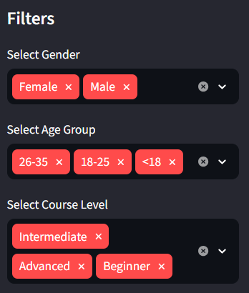
Fig.1. Sidebar Filters for Learner Demographics Analysis

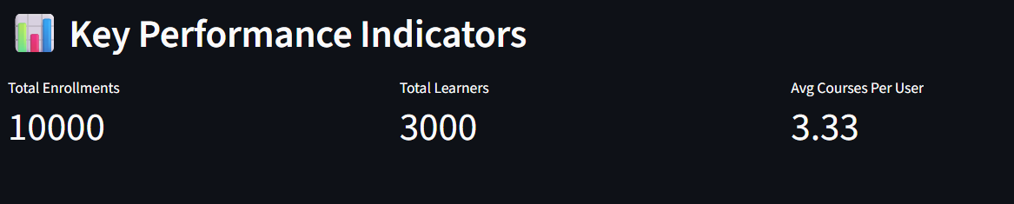
Fig.2. Key Performance Indicators (KPIs) of the EduPro Learner Demographics Dashboard

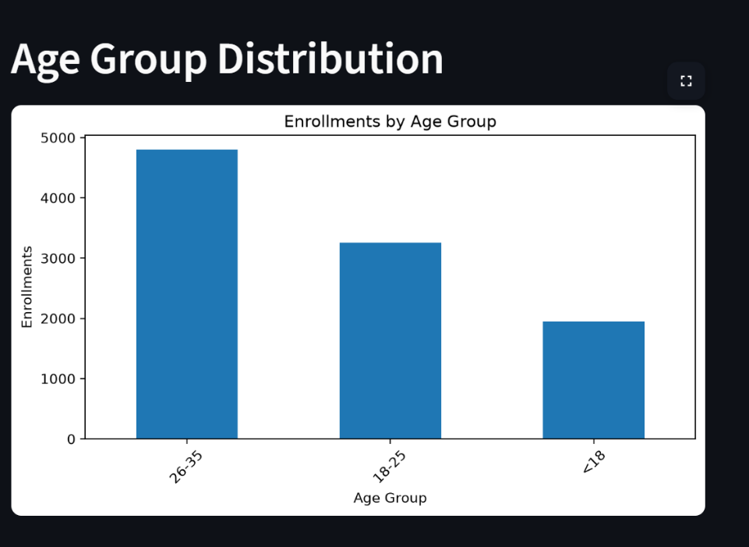
Fig.3. Age Group Distribution of Learner Enrollments on the EduPro Platform.

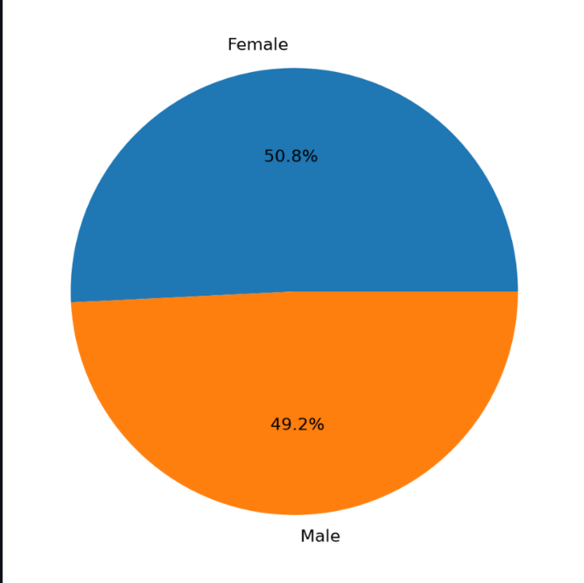

Fig.4. Gender Distribution of Learners on the EduPro Platform.

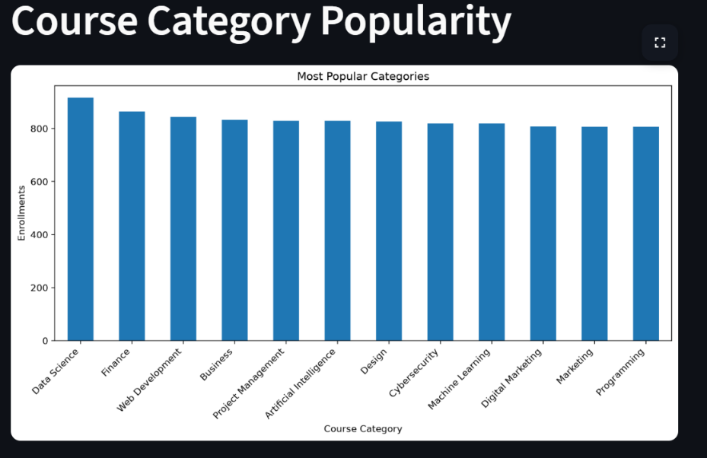
Fig.5. Course Category Popularity on the EduPro Platform

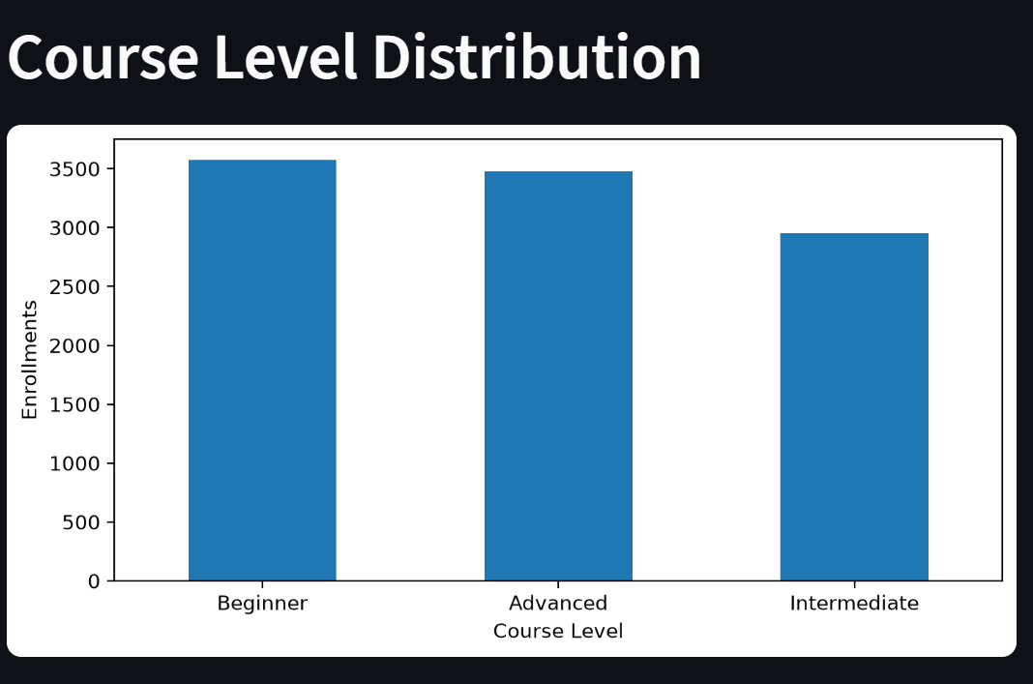
Fig.6. Course Level Distribution on the EduPro Platform

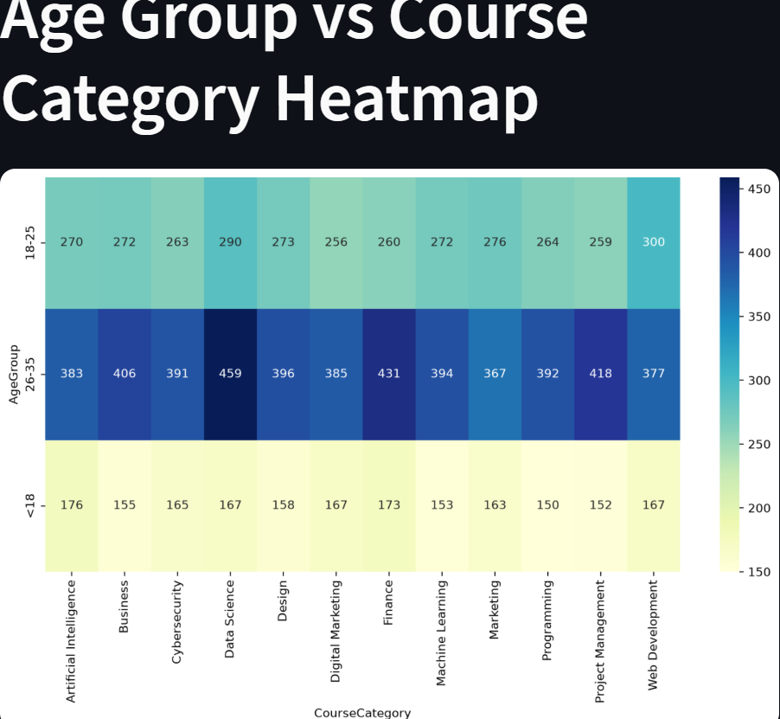
Fig.7. Age Group versus Course Category Enrollment Heatmap on the EduPro Platform

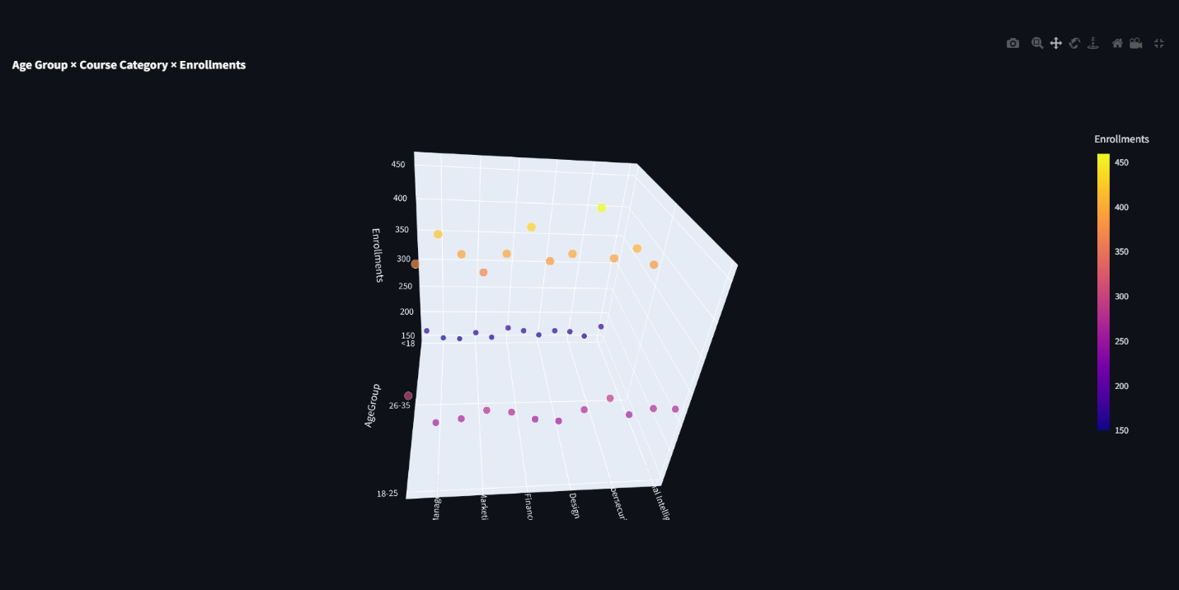
Fig.8. 3D Scatter Plot of Age Group, Course Category, and Enrollments

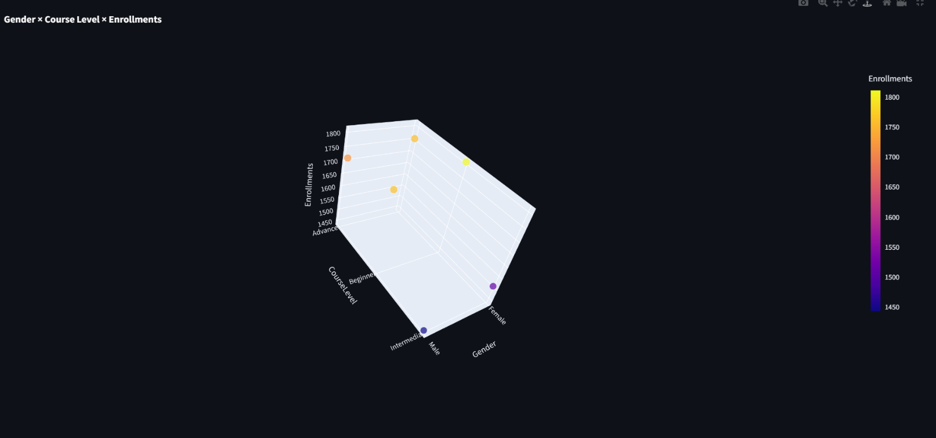
Fig.9.Gender × Course Level × Enrollments

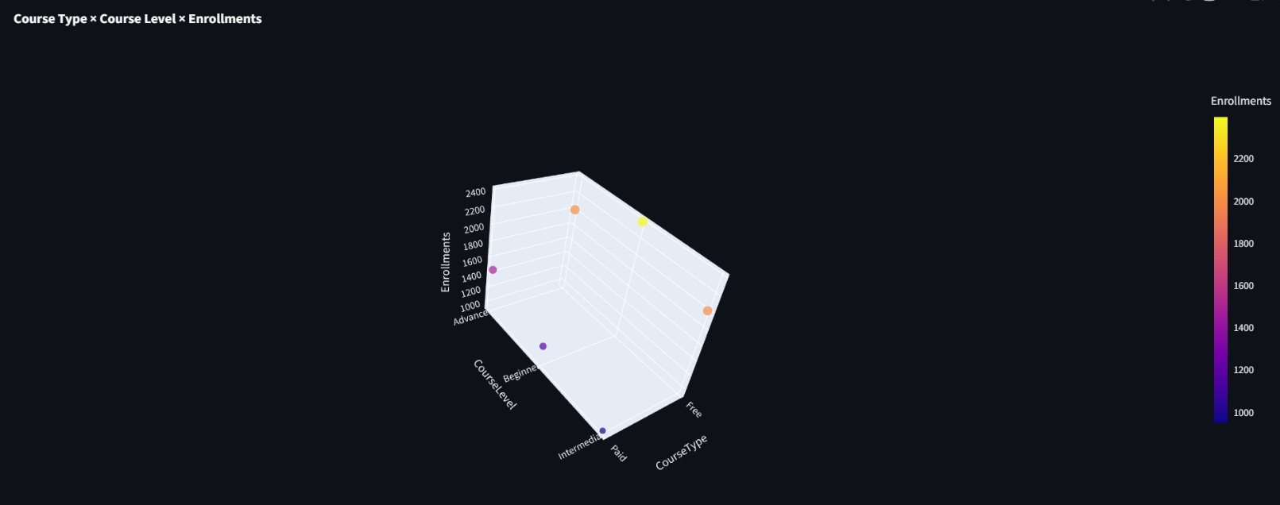
Fig.10.Course Type × Course Level × Enrollments

